|  |  |
| --- | --- |
| **Name** | **Adil Khalil Akhmed** |
| **UNIT number & name** | Unit 0: Website Development |
| **Academic year** | 2025-2026 |
| **Unit Lecturer** | Ms. Rizwana Zulfiqar |
| **Assignment Title** | Creating Website for Golf Resort Company |
| **Type of Assignment** | Business Report |
| **Issue Date** | 07/04/2025 |
| **Summative Submission Date** | 30/04/2025 |

# A.P1-Explain, using appropriate definitions, the characteristics of different methodologies applied in IT projects.

**Prince2:** A structured process-based methodology focusing on clear stages of the roles and responsibilities. This is best for large scale projects with large teams**.** Pros**;** it is well structured and mainly focuses on business justification, whilst its Cons are that it is heavy on documentation due to its large overall size. The user requirements are controlled by change process and emphasizes with the business objectives and stakeholder expectations.

**Waterfall:** sequential approach Where each stage must be done step by step in order to move to the next progress. This is best for projects that need minimal changes and are already well-defined. Pros; clear timelines and documentations, whilst its Cons are that it is inflexible to change and reveal major issues on testing phase. The user requirements of feedback are gathered at the beginning stage of the planning which works well when requirements are unlikely to change. Quality

**Agile:** A flexible methodology that focuses on adaptive planning and continuous feedback. This is best for projects that require frequent collaboration and flexibility. Pros; costumer involvement and changes based on responses. Whilst the Cons are that it needs disciplined team and could increase the risk of scope creep risk.

# A.P2 - Explain the Project Management Structures Applied in Different IT Projects:

**Prince2:** The user requirements are controlled by change process and emphasizes with the business objectives and stakeholder expectations. Whilst the Quality approach is through product-based planning through which acceptance standards are defined upfront, quality assurance and control make sure that it meets with the expectations of the team and developers, this impacts the Strong governance and accountability ensure consistency and traceability but can be project heavy.

**Agile:** The user requirements are largely flexible and continuously refining whilst also encouraging collaboration with users between different phases in which allows for quick adaptation of user needs. Whilst the quality approach is set of continuous testing included with the user feedback, this also Promotes high adaptability and early error detection but also requires strong team discipline and testing practices.

**Waterfall:** The user requirements of feedback are gathered at the beginning stage of the planning which works well when requirements are unlikely to change. Whilst the Quality approach is set from rigid phases and formal testing with detailed requirements serving as the foundation. This Ensures thorough documentation and testing, but late discovery of defects can delay delivery and increase costs.

# A.M1 - Compare the Characteristics of Different Methodologies.

|  |  |  |  |
| --- | --- | --- | --- |
| Aspect | PRINCE2 | Agile | Waterfall |
| Approach | Pro | Sequential | Linear |
| Flexibility | Moderate | High | Low |
| Testing | Quality control | Continuous | After Phase completion |
| Documentation | Extensive | Minimal | Extensive |
| Costumer Involvement | Moderate | High | Low |
| Planning | Product based | Incremental | Upfront |

# A.D1 - Evaluate the Characteristics of Different Methodologies.

* **Prince2 Strength:**

Structured approach: Offers a clear approach of project management that helps to split certain work into different segments that allows for review and check the overall progress of the score. This approach is highly useful especially for project managers to manage the complex work once certain segments are completed.

Product-based Planning: Since planning resolves around the product, this encourages the project team to focus on value and the quality of the project rather than just completing the given task

Review and Feedback: with the process of project team conducting planning and control checks at the end of a phase to conclude the performance and resolve certain error that would occur especially with the feedback given by costumers and project team to make any necessary changes, this means that changes are made regularly that also increases the rate of the overall projects success

* **PRINCE2 Weakness:**

High documentation requirement: This methodology requires high amounts of complex documentations which is time consuming especially if it’s a small-scaled project. The process of documenting everything also creates the problem of time management and loosing track of correct documentation for the correct phase which can lead to risk of misunderstanding in the future.

Rigidity: A structured approach can seem too formal in which can limit the team’s creativity and as project managers will be restricted in implementation that can impact in slow responsiveness to make changes.

Resource Intensive: With this methodology with high rigidity and limited flexibility, it is only right to have the right amount of resources and correct people that can help bring it all together, this is why it is difficult for smaller scaled teams with fewer resources to create completed projects with a PRINCE2 approach and due to the significant demands it places on people and time.

# B.P3-Research with some inconsistencies an IT problem, based on a given theme and scope out at least two alternative solutions.

With given responsibility of managing the IT project, with noted issues of low costumer engagement and poor app functionality from low amount of features, noted down are two solutions that I have researched that can help in resolving the issue:

**Fullstory:**

Fullstory accesses cloud security issues across cloud environment and help optimize user experience. It allows for the project team to track and monitor user activity by automatically indexing and recording all interactions.

Impacts:

* Identifies points of user struggle
* Improve UI based on real behaviour
* Providing insight for enhanced user flow and engagement

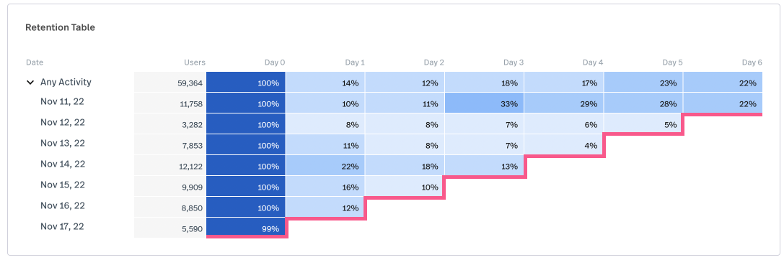

**Junit:**

Framework designed for unit testing of java, this allows for developers to test individual functionalities and run tests to check for the outcome, when test fails Junit provides feedback of the issue for the developers in order to debug their code.

Impacts:

* Ensuring features of code work accurately
* Catch and report back bugs that are detected
* Increase in trust of projects performance

# B.P4-Prepare with some inconsistencies a feasibility study on an IT project and select a preferred solution.

Feasibility study is a process of helping to understand if accessing the proposed project is viable and worth pursuing. It helps project managers determine if the project should go ahead, be changed, or be abandoned. The goal is to reduce risk, identify potential problems, and ensure that the project is technically, economically, and operationally achievable before investing significant time and resource.

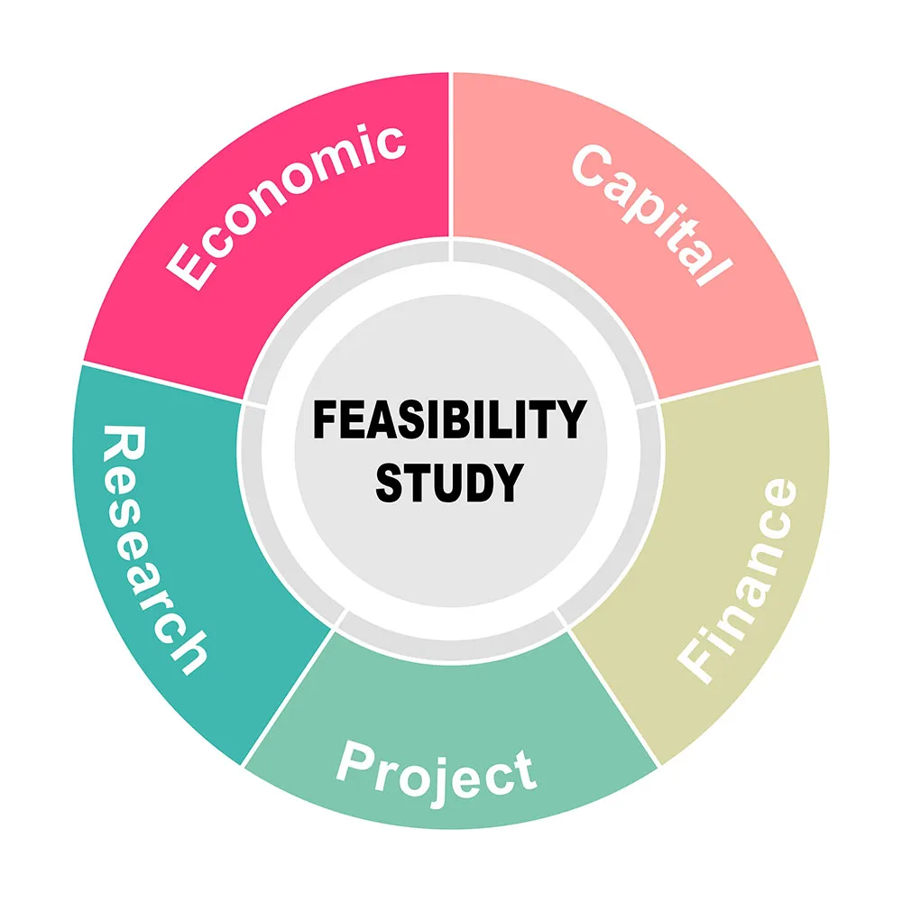

Technical Feasibility:

Help access to understand the given tools and system architecture meet the project requirements, this helps evaluate if the project team has the necessary skills needed for the overall project to be a success.

Economic Feasibility:

Access the cost effectiveness of the project by comparing the costs of the project for development that includes the total cost for the final development like hardware and software resources required, this helps determines if the project offers a worthwhile return on investment and is financially viable.

Operational Feasibility:

Access if the proposed system will function effectively and maintenance after deployment, other scopes of this feasibility is that to help determine the usability of the product and suggesting solutions.

Schedule Feasibility:

Accessing the right timeline in which the project needs/will be complete. It also assesses whether deadlines are realistic given the scope, resources, and constraints.

Resource Feasibility:

Reviews the required resources such as equipment, hardware/software and budget. This helps for the project team to understand if they have the scope and capacity to support the project from start to finish.

Legal Feasibility:

If the project complies with the relevant laws as per the projects category, such as data protection licensing and compliance in order to avoid future issues for the client.

# B.M2- Assess consistently at least two adequately researched solutions to an IT problem on a given theme and recommend a preferred solution.

Assessment of Fullstory: Behavioural analytic tool helping developing team understand user interactions within the project, capturing and recording detailed engagements. In sense of current problem being customer retention, then fullstory would be valuable to use as it shows what and why the current thing is happening giving insights to developers and project managers for better improvements on the UI. It is also important to note that fullstory does not help in fixing bugs and resolving the overall issue by itself but helping in giving valuable information for the project team and help prioritize in understanding which usability is being affected the most.

Assessment of Junit: Used in testing out code of the project to ensure that they function. It also helps in addressing poor functionality, JUnit is a core solution. It helps developers verify system behaviour by catching bugs early on. Although Junit operates in code level and only gives feedback to developers on what code has a bug.

**Recommendation:** Both solution tools are valuable on their own way, but fullstory would be good as it gives a more impactful solution since customer retention is a high concern, It also provides actionable insights into real user behaviour, which allows the team to enhance the UX and increase engagement.Whilst JUnit is critical for long term code fixing and quality, its main purpose is to address the creativeness of features. I personally feel to recommend Fullstory as it can help giving best results providing visual insights for developers easy understanding whilst also prioritizing UX improvements to help increase customer retention.

# C.P5- Plan with some inconsistencies and/or omissions the implementation of an IT project.

We are to create a customer Relationship Management (CRM) in order to help manage customer interaction and improve the customer retention

**Planning:**

|  |  |  |
| --- | --- | --- |
| **Phase** | **Duration** | **Description** |
| Planning | 1 Week | Create goals and requirements |
| Design | 2 Week | Making up the architecture of the project from planning phase |
| Development | 4 Week | Build of frontend and backend of the project |
| Testing | 1 Week | Test for any inconsistencies |
| Deployment | 2 Days | Launch of the overall project |

Inconsistency:

* Deployment phase is too short
* No mentions of using the Agile Methodology

**Budget:**

|  |  |
| --- | --- |
| **Overview** | **Estimated Cost** |
| Development Tools | $1,500 |
| Employee Salaries | $7,000 |
| Marketing | $3,000 |

The budget covers the essential needs in order to create our CRM system, however it lacks allocation for critical areas such as quality assurance, data security and system maintenance.

Omissions:

* Quality assurance
* Lack of security infrastructure
* Provided training for development team
* Lack of Backup and recovery solutions

**Resource Allocation:**

Project Manager: Help oversee and coordinate project timelines and other objectives are met.

Lead Developer: help the team and coordinate the frontend and backend of the project development including system architecture

Intern: Assist the team with testing, although would not recommend for tasks such as quality assurance in absence of managers.

Omissions:

* Lack of training
* Lack of support post development phase
* No security expert

# C.P6-Execute with some inconsistencies and/or omissions the implementation of an IT project.

**Phase 1 (Planning):**

Project objectives/goals: Improve customer engagement and automate for better app functionality and communication.

Stakeholders: Project Manager, development team, customers

Budget: Approved ($15,000)

Inconsistency:

* No agile artifacts created such as backlogs, user feedback
* Lack of stakeholder engagement not actively involved in the requirements or goals
* No defined scope of exact features, timeline and success metrics not clearly stated
* Requirements were gathered informally through team discussion

**Phase 2 (Designing):**

Wireframe and mock-ups: create wireframes to map out interface layouts, also create high fidelity UI mock-ups using various tools such as Figma or Adobe.

Review & approval: conducting internal reviews to gain sense of certain design improvements that need to be made before the final sign off.

Architectural design: outlining the software architecture including major components such as data flow in order to collaborate with lead developers to finalize the endpoint of database relations.

Inconsistency:

* Incomplete design scope
* Lack of design system and style guide provided
* Lack of user involvement from user feedback

**Phase 3 (Development):**

Security: implementing user authentication with a role based access control for the developing team, ensuring password encryption in which can protect users data against common web vulnerabilities.

Integration: Integrating third party tools such as emails and analytics to ensure perfect data handling and error management.

Collaboration: regular check ups from developers, project managers and designers in which uses Agile and Kanban boards for the process.

Inconsistency:

* Security only partially implementing
* Lack of peer testing
* Agile not properly followed

**Phase 4 (testing):**

Functional Testing: verifying all the features and functions correctly without any errors across use cases, making sure to check for validations and system responses.

Bug tracking/fixing: retesting logged issues and addressing defects to make a resolution in the future.

Security Testing: Checking for common vulnerabilities through SQL and injection. Having verified password handling across different user roles.

Inconsistency:

* Lack of Automation regression tests were implemented
* Untracked bug reporting
* No formal test plan created

**Phase 5 (Deployment):**

Code deployment: deploying the application code in which the developing team created for the overall project whilst also ensuring database migration and backend services are executed properly without any errors.

Monitoring: Implementing monitoring tools to keep track of system, detect and respond to issues quickly, also monitor for any performance drops of the application including of any server downtimes.

Post-launch Review: holding a launch-day retrospective with the developing team and review the process of immediate results, also making sure to collect user feedback through surveys since in use of Agile methodology.

Inconsistency:

* Manuel deployment process
* No formal recovery plan
* Lack of backup validation before launch

# C.P7-Monitor and control with some inconsistencies and/or omissions the implementation of an IT project.

**Implementing Fullstory to monitor and control within the IT project**

**1.User behaviour:** observing real user sessions of the application to identify patterns of replays in which users have struggled in using the key features of the application, having some errors during form submissions. Nonetheless observations were done inconsistently and lacked segmentation by user role or device type.

**2.Integration:** Fullstory session recording script in which is embedded into the CRM frontend interface, this allows for the platform to begin tracking users interaction within the application such as clicks, copies, scrolls and navigation paths. However these integrations were mainly focused on desktop views leaving out other devices such as tablets and phones which were untracked.

**3.Stakeholder involvement & reporting**: After collecting user behaviour data through FullStory, a limited summary of key findings was shared with internal stakeholders, including managers and the product team. The insights focused on a few observed pain points, such as navigation issues and repeated errors during form submissions. However, these findings were communicated in an informal manner often through verbal updates or brief emails without the support of a structured reporting format.

No regular reporting schedule was established, and data visualization tools were not used. This made it difficult for decision-makers to fully understand user engagement trends, track progress over time, or prioritize feature improvements effectively. Additionally, the lack of clear documentation meant that important insights may have been lost or misinterpreted, reducing the long-term value of the monitoring process.

**4.Data interpretation and Analysis:** Once FullStory began collecting user session data, the project team performed a basic manual review of selected session replays and heatmaps. These insights highlighted where users were dropping off, hesitating, or showing signs of frustration. However, the analysis lacked structure and strategic depth, there were no predefined success metrics or KPIs (Key Performance Indicators) to guide the evaluation.

**5.Issue Detection & communication:** FullStory provided valuable real-time insight into user struggles and system bugs through its session replay and console error tracking features. During the monitoring phase, the team was able to observe recurring technical issues such as failed form submissions, unresponsive buttons, and confusing page transitions all of which contributed to poor functionality and reduced user satisfaction. Although reporting the issues were informal and lacked structure, developing team were mainly notified through direct messages or verbal communication and there was no use of a centralized bug-tracking tool to log, categorize, or prioritize the problems.

# C.M3- Perform soundly and consistently appropriate project management processes to implement an IT-based project.

**Appropriate management process for Fullstory within the IT project**

**User requirements:**

Once data is gathered the developing team synthesizes it into personas, these personas include goals, challenges, and behavioural patterns. Creating personas helps the team empathize with different user types and ensures that feature decisions are grounded in actual user needs rather than assumptions. The team also creates journey maps to visualize how each persona interacts with the system, spotlighting areas that cause confusion or disengagement.

**Risk Management:**

integrating FullStory into the project, the team begins by identifying potential risks that could negatively impact system performance, user privacy, and the quality of insights gathered. Key risks include the possibility of capturing sensitive user data inadvertently, making incorrect decisions based on misunderstood session data, or encountering compatibility issues between FullStory’s tracking script and the existing software stack. Additionally, there’s a risk that the team might not fully utilize FullStory’s capabilities, resulting in wasted budget and effort.

* Data privacy violation🡪Critical
* Incorrect Insight Usage🡪Significant
* Conflict with UI🡪Moderate

Once risks are identified, they are analysed based on two key factors: how likely they are to occur, and what level of impact they could have on the project. In contrast, a UI conflict caused by the FullStory script might be less impactful but still worth monitoring. This analysis helps the team prioritize which risks need immediate attention and which can be monitored more casually.

**Management processes:**

project begins by clearly outlining what the organization hopes to achieve with FullStory. This could include improving user experience, reducing drop-off rates, identifying bugs in real-time, or increasing feature engagement. The scope is defined to ensure the team knows exactly which areas of the application FullStory will monitor and analyse. Deliverables, milestones, and boundaries are documented to prevent scope creep and to align team expectations.

**Final Results:**

An appropriate management process for achieving a consistent and successful result with FullStory involves clearly defining project goals, implementing FullStory in stages, continuously monitoring user behaviour insights, and regularly reviewing findings with stakeholders to ensure alignment with user needs. This process ensures consistent data collection, actionable insights, and integration of findings into product improvements, leading to a refined user experience and measurable project success.

4o

|  |  |  |  |
| --- | --- | --- | --- |
| **Objectives** | **In progress** | **Testing** | **Final Deployment** |
| Define project goals and KPIs for FullStory | Configure masking and privacy settings | Tag critical user actions (clicks, forms) | Deploy FullStory to live environment |
| Identify key user journeys to track | Set up event tagging framework and guideline | Conduct session replay tests | Train teams to use FullStory insights |
| Conduct stakeholder alignment meeting | Embed FullStory tracking script in staging | Review and approve insights dashboard setup | Begin monitoring user behaviour and reporting |
| Document success criteria and deliverables | Conduct internal demo and gather feedback | Validate event tagging accuracy | Gather feedback and iterate on tagging and setup |

# BC.D2- Evaluate consistently and comprehensively at least two researched and realistic solutions to an IT problem on a given theme and justify using logical chains of reasoning a preferred solution.

**Introduction:**

The company is facing two major challenges that are negatively impacting the performance of the application which are low user engagement and poor website functionality. Users are not interacting with key features and are frequently dropping off due to issues like slow performance and confusing navigation. These problems are hurting customer retention and overall business growth. To address this, better insight into user behaviour and technical performance is needed.

**Fullstory and Junit:**

FullStory provides heatmaps, conversion funnel analysis, and event tracking to help UX designers, developers, marketers, and product managers gain actionable insights. One of its most valuable features is the ability to segment user behaviours and filter sessions based on specific actions or technical events. FullStory also includes strong data privacy tools, such as masking of sensitive inputs, ensuring compliance with data protection laws. Whilst Junit is a widely used open-source testing framework for Java applications that allows developers to create and run unit tests. It enables precise testing of small, isolated units of code—typically individual methods or classes—to ensure they behave as expected. JUnit supports test-driven development, a methodology where developers write tests before the actual implementation, promoting clean, modular, and error-resistant code.

**Cost & scalability:**

Fullstory has a subscription-based payment method in which varies depending on the number of sessions that are tracked and the depth of the analytics that is gathered. For startup businesses such as us, the cost can be significantly expensive especially if session volumes are high. However, the investment is often justified by the actionable insights FullStory provides, which can lead to improved user retention and reduced development waste. Fullstory is also highly scalable which is suitable for our small team since the tool can handle increasing volumes of session data and support more complex tracking needs. It also integrates well with platforms like Segment, Slack, and Jira, which enhances team collaboration and long-term usability across multiple departments.

Whilst JUnit is a free open source which is extremely cost effective that requires no payments/subscriptions and licenses to operate, which is ideal for our team, since it’s widely supported in the Java ecosystem, most developers are already familiar with it, reducing onboarding and training costs.

**Evaluation and Justification:**

Fullstory has been chosen by the team as the main solution to cover up the problems that the company is facing, this is because it provides with the ability to have visual session replays and track in real-time the behaviour insights, allowing the team to observe exactly how users interact with the site. It was also chosen for its ease of scalability that integrates smoothly with existing web infrastructure and requires minimal setup time, making it a practical choice for teams with limited development resources in which makes it an ideal solution for diagnosing user experience issues and driving meaningful improvements across the digital product.

|  |  |  |
| --- | --- | --- |
| **Criteria** | **Fullstory** | **JUnit** |
| Cost | Subscription-based; can be expensive for large-scale usage | Free and open source; no cost for usage |
| Scalability | Highly scalable with growing user base; handles large volumes of data well. | Scales efficiently in large codebases and CI/CD pipelines |
| Effectiveness | Very effective for identifying UX/UI issues and improving engagement. | Highly effective for catching bugs and ensuring code reliability |
| Ease of Use | User-friendly interface; requires minimal technical skills to analyse data. | Requires programming knowledge; easy for experienced Java developers |
| Customizability | Offers customizable dashboards, tagging, and event tracking. | Fully customizable for test design and integration into development. |

# BC.D3-Perform consistently and effectively appropriate project management processes to implement an IT-based project.

**Execution and Resource Allocation:**

The implementation team will configure key features such as session replay, heatmaps, funnel tracking, and event tagging to align with project objectives particularly targeting areas of low engagement and poor functionality. Initial data is analysed collaboratively by developers, UX designers, and product managers to identify immediate issues and prioritize improvements, user segments are created in order to gather and create personalized insights of each user, throughout the execution there will be continuous monitoring to ensure data privacy and application is well adjusted.

**Risk Management:**

the potential for FullStory’s script to impact page load times. This is addressed by testing the script in staging environments before full deployment and monitoring its performance in production. There is also the risk of misunderstanding the behavioural data, which could lead to misguided changes. To mitigate this, behavioural insights are cross-checked with other analytics tools and user feedback. A risk register is maintained throughout the implementation to document identified risks, assess their impact and likelihood, and assign mitigation owners.

Issue tracking with FullStory is both proactive and reactive. As users interact with the website, FullStory records sessions and flags issues such as rage clicks, broken elements, and dead-end pages. These issues are automatically logged and categorized within the platform. The integration of FullStory with tools like Slack or Jira also enables automated issue reporting. For example, if FullStory detects a spike in user frustration or JavaScript errors, an alert can be triggered and instantly assigned to the development team. This structured process ensures that issues are not only identified in real time but also tracked to resolution efficiently, improving product quality and user satisfaction over time.

**Stakeholder Input:**

Throughout the project, stakeholders are given access to tailored dashboards and session highlights that reflect areas of concern (e.g., checkout abandonment, low product engagement). Regular feedback sessions are held where stakeholders can review findings, propose hypotheses, and suggest new focus areas based on ongoing insights. Stakeholder feedback is documented and integrated into the project backlog, helping prioritize enhancements and aligning technical decisions with business objectives. This collaborative approach ensures FullStory is not just a technical tool, but a strategic asset shaped by those invested in the project’s success.

**Monitoring and Control:**

To control the quality and consistency of data, the team conducts regular audits to ensure that sensitive information is being properly masked and that any changes to the site (such as UI updates) are reflected in FullStory’s configuration. Alerts and tagging updates are managed to ensure continued relevance as the website evolves. The monitoring process includes stakeholder check-ins and report sharing to align on findings and decide on corrective actions. If unexpected issues arise such as performance slowdowns or missing events, the implementation team responds quickly by revisiting the tracking setup or coordinating with FullStory support.

**Gantt Chart:**

|  |  |  |  |  |  |  |
| --- | --- | --- | --- | --- | --- | --- |
| **Criteria** | **Date** | | | | | |
|  | **May-13** | **May-17** | **May-23** | **May-30** | **June-5** | **June-7** |
| Deployment-monitoring |  |  |  |  |  |  |
| Deployment |  |  |  |  |  |  |
| Testing |  |  |  |  |  |  |
| Setup & integration |  |  |  |  |  |  |
| Requirement gathering |  |  |  |  |  |  |
| Planning |  |  |  |  |  |  |

# D.P8- Explain how project management skills were used in the management of an IT project.

**Planning and Organization:**

A detailed project plan was developed in which outlines key phases such as requirement gathering, tool configuration, testing, deployment, and post-deployment monitoring. This plan helped to define the project scope, allocate resources, and set a realistic timeline. Tools like Gantt charts and task tables were used to visually organize responsibilities and track progress.

**Risk Management:**

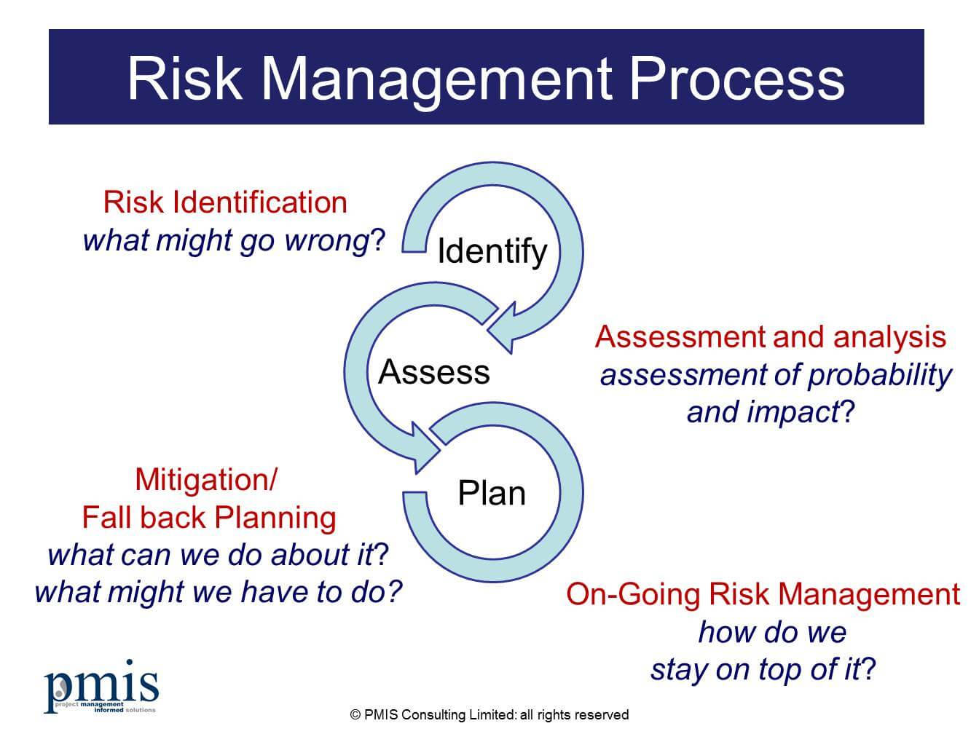Risks such as data privacy issues, integration challenges, or misinterpretation of user data were identified early. Mitigation strategies such as enabling masking features in FullStory and testing in a staging environment were implemented, demonstrating proactive risk planning and control.

**Monitoring and Control:**

monitoring helped track key deliverables and identify deviations from the plan. Regular reviews of FullStory data ensured the tool was delivering accurate insights, while updates to dashboards and task tables helped maintain clarity on current progress and outstanding actions.

**Evaluation:**

continuous evaluation As new user behaviour data emerged, priorities were adjusted. This agile responsiveness ensured the project stayed focused on solving the real problems: low customer engagement and poor website functionality. This adaptability reflects strong project management skills, where feedback loops are used to inform decision-making. Instead of rigidly sticking to the initial plan, the team remained flexible, updating goals, timelines, and resource assignments as needed. This iterative evaluation and adjustment process ensured that the project remained relevant, user-cantered, and outcome-focused, ultimately increasing the effectiveness and value of the FullStory integration.

# D.P9-Explain how relevant behaviours were applied during the management of an IT project.

**Clear Communication:**  
Open and regular communication was maintained across all teams including developers, stakeholders, and end users. Meetings, reports, and visual tools like dashboards and Gantt charts were used to ensure everyone understood project goals, timelines, and outcomes.

**Responsiveness and Adaptability:**  
The team remained flexible and responsive to changing requirements and unexpected issues. For instance, when early FullStory data revealed unexpected user drop-offs, the team quickly adapted priorities to address usability flaws that weren’t originally scoped.

**Collaborative Decision-Making:**  
Stakeholder input was actively sought at all key stages, especially during the requirement gathering and analysis phases. Their feedback shaped how FullStory’s tools (such as event tagging and funnel tracking) were configured to meet real business needs.

**Accountability and Ownership:**  
Team members were assigned clear roles with responsibilities, such as integrating scripts, analysing data, or managing risk. Each member was held accountable for their tasks, which helped maintain progress and reduce delays.

**Problem-Solving Mindset:**  
When technical or data privacy issues arose such as concerns around capturing sensitive user data these were handled proactively with ethical and compliant solutions, like enabling FullStory’s masking features and involving the compliance officer.

**Attention to Detail:**  
Precision was key, especially when configuring what events to track or interpreting user session data. Careful attention ensured that decisions were based on accurate insights rather than assumptions.

**Time Management:**  
The project followed a structured timeline with phased planning e.g., requirement gathering, testing, deployment, helping to keep the implementation on track and within the projected schedule.

# Reference

**1**.GeeksforGeeks (2024) *Types of feasibility study in software project development*, *GeeksforGeeks*. Available at: https://www.geeksforgeeks.org/types-of-feasibility-study-in-software-project-development/ (Accessed: 19 May 2025).

**2.***PRINCE2* (2025) *Wikipedia*. Available at: https://en.wikipedia.org/wiki/PRINCE2 (Accessed: 30 May 2025).

**3.**Atlassian (no date) *Waterfall methodology for project management*, *Atlassian*. Available at: https://www.atlassian.com/agile/project-management/waterfall-methodology (Accessed: 30 May 2025).

**4.**Atlassian (no date b) *What is agile?*, *Atlassian*. Available at: https://www.atlassian.com/agile#:~:text=What%20is%20the%20Agile%20methodology,more%20responsive%20and%20successful%20outcomes. (Accessed: 30 May 2025).

***5.****The Pros and cons of waterfall methodology* (2018) *Lucidchart*. Available at: https://www.lucidchart.com/blog/pros-and-cons-of-waterfall-methodology (Accessed: 30 May 2025).

**6.**TheKnowledgeAcademy (no date) *PRINCE2 methodology Advantages & disadvantages - A complete guide - united kingdom*, *The Knowledge Academy - Online certification training courses provider*. Available at:

**7.**https://www.theknowledgeacademy.com/blog/what-are-the-advantages-and-disadvantages-of-prince2-methodology/ (Accessed: 30 May 2025).

**8.**Kukhnavets, P. (2021) *Agile Strengths and weaknesses*, *Hygger*. Available at: https://hygger.io/blog/agile-strong-and-weak-points/ (Accessed: 30 May 2025).

**9.***Project execution* (no date) *Project Management*. Available at: https://research.unl.edu/projectmanagement/execution/ (Accessed: 28 May 2025).

**10.** *Project Risk Management Process: Assessment, Lifecycle Approach (2021) PMIS Consulting Limited. Available at: https://www.pmis-consulting.com/articles/project-risk-management/ (Accessed: 30 May 2025).*